
Software Requirements Specification
for
Chishti Designers and Builders
Version 1.0

Prepared by
Group Name: MCS Approved Installers
Capt Jamal Ahmad | BS-16B | Jamal_ahmad@mcs.edu.pk
Capt Sumeer Riaz | Bs-16B | Sumeer_Riaz@mcs.edu.pk
PC Sundus Asim | Bs-16B | gemni@mcs.edu.pk

Instructor: | Dr. Arif Raza
Course: | Software Engineering (Network Stream)
Lab Section: | BESE-16B
Date: | Monday, October 22, 2012.
Contents
Revisions i
1 Problem analysis 1
1.1 Document the problem by gaining agreement 4---------------------3
1.2 understand the root causes 4---------------------7
1.3 identify the stakeholders 5---------------------9
1.4 define system vision and boundary 5---------------------9
1.5 identify the constraints 5-------------------12



NoTe :-

- All the effort in this project is based on reality

- The project in being made for an construction company in Lahore

- The project was taken about three weeks back and work on its development has already started.

- The under mentioned company / owner may be approached for necessary verification.

REVISIONS
Version | Primary Author(s) | Description of Version | Date Completed
1.0 | MCS Approved Installer | Creating | 22/10/12

PROBLEM ANALYSIS

INTRODUCTION
Chishti Designers and Builders are a well renowned construction company. Due to their ever increasing business in the market and increasing number of customers, maintaining the record of customers on registers and files started becoming difficult for them. Purpose is to design a system for them in order to reduce their work overhead for maintaining the record of the customers. Presently all the customer’s data is maintained by the clerks on registers, files and company correspondence pads.
PROBLEM ANALYSIS
1.1 Document The Problem By Gaining Agreement
We had an informal conversation with them on telephone in which the problems being faced by them were discussed. Initially the problems being faced by them are stated as under:-
1.1.1 Problem
Poblem Description | Slow data entry of new customers
Affects | Clerks, Managers, Supervisors, Customers, Company
Results | A lot of time was required to create a new page of, add columns and take input from the customers and write them manually on registers and files. In addition if some customer’s record has to be searched then it takes a lot of time to get the required register and open the relevant page. Customers had to wait a lot and work burden increases on the clerks, which ultimately affects the supervisor and the business of construction company.
Benefits | The office automation system provided by our new software will provide quick data entry of the customers, since the forms will be automatically generated by the software system and searching a particular record is only a click away.

1.1.2 Problem
Poblem Description | Extra time consumed in updating a customers data that involves unnecessary duplication.
Affects | Clerks, managers, supervisors, customers, company
Results | A lot of time was required to update a customer’s data as it involved duplicating the complete record with updated credentials on a new register page. This process is very slow and involves unnecessary paper wastage, destruction of old record (as it’s not of any use). Work overload increases on clerks and it’s difficult for managers to sort and manage the database.
Benefits | The system will update the record of customer with a single click and replace the old data with the new details entered. A relatively extremely fast process. No unnecessary paper / printer wastage

1.1.3 Problem
Poblem Description | No backup of the customers data
Affects | Clerks, managers, supervisors, customers, company
Results | Company was not maintaining any backup as it was quite a lot difficult for them to duplicate the existing registers and files. It would almost double the workload on the clerks and would be difficult for the managers to manage the expenditures on duplicating the data. Both company and customers will be affected if any of the data is lost. In addition it is humanly not possible to update the original and backup data if held by the company.
Benefits | In the office automation system provided by our new software backup of the customers data will be created both in the encrypted form (not visible to anybody, only readable by software) and in the visible form. So, even if one computer crashes the database will be maintained on the server and other computers can easily access it.

1.1.4 Problem
Poblem Description | Delay in project management as any register or file cannot be used concurrently by more than one clerk.
Affects | Clerks, managers, supervisors, customers, company
Results | Processing the contract is very slow as data of a customer cannot be accessed by multiple clerks/ managers / supervisors at one time since it is stored in one file. This makes the processing very slow and becomes a stumbling block in the way of quick and efficient record handling.
Benefits | Our system is designed to keep the database on the central server and master computer. All the computers will have the access to that data. However the rights provided will be limited as per the authority and rank of the user.

1.1.5 Problem
Poblem Description | No authorized access i-e anybody can get hold of files and see personal record of customers.
Affects | Clerks, managers, supervisors, customers, company
Results | Since the record keeping is presently done on files and supervisors had to access the files through clerks, therefore there was no element of privacy of the customer’s data. Any record could be mishandled by anybody.
Benefits | Our system will provide limited rights to the users according to their appointment in the office, every user cannot delete / update / view all the records of the customers.

1.1.6 Problem
Poblem Description | No verification of the customers data /address according to cnic.
Affects | Clerks, managers, supervisors, customers, company
Results | Company had to face a lot of problems in getting the verification of the address/ name and cnic of a particular customer which was quite time consuming (in property and construction buisness cnic verification is an important issue and cannot be neglected) .
Benefits | Our system will provide automated online verification through the nadra website regarding the credentials of any new customer

1.1.7 Problem
Poblem Description | No reminders to help users remember important tasks and meetings.
Affects | Clerks, managers, supervisors, customers, company
Results | Clerks, managers and supervisor faced the problem of at times forgetting the important tasks, meetings and events due to which the company had to face a lot of problems. There was no mechanism which can remind them of the important events.
Benefits | Our system will give the additional facility of adding reminders on different dates and users can view the daily to-do tasks on their computer desktop. This will increase the efficiency to a great extent

1.1.8 Problem
Poblem Description | A lot of paper and printer wastage in getting drafts finalized.
Affects | Clerks, managers, supervisors, customers, company
Results | Company had to bear the overhead of the expenses of the pages and printers to get the drafts finalized.
Benefits | The drafts will be finalized on the computers by marking them to the required appointment and will be printed only once the document is finalized by the competent authority. This will reduce the paper and printer‘s cost overhead to a great extent.

UNDERSTANDING THE ROOT CAUSE
1.2.1 Understand The Root Cause. There were many important issues with the company like not maintaining backup, laziness on the end of clerks to process a case and tending to forget the important events and tasks. However after analyzing all the problem and their effects on the business activity the root cause was found to be that they were still using old methods of record keeping and data storage.

S.No | Causes | Percentage Affecting Company
1. | Not maintaining backup of customers record | 20 %
2. | Laziness of Clerks | 15%
3. | Negligence and forgetting tasks | 5%
4. | Using Old Method Of Record Keeping (on papers) | 60%

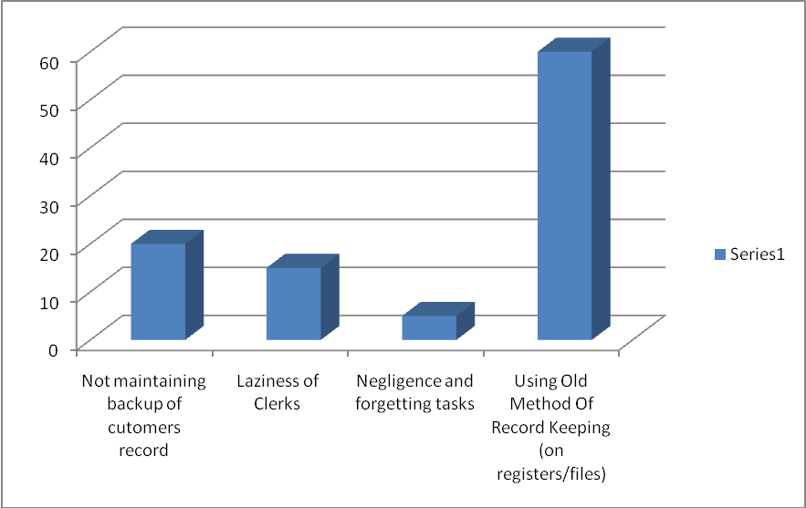

1.2.2 Root Cause :-

Poblem Description | Using old method of record keeping on papers.
Affects | Clerks, managers, supervisors, customers, company
Results | It effected the business routine of the organization as under :-  - More time required for data entry, extra employees needed to be hired  - No duplication/backup, the company will be at loss in case of any file damage /loss.  - Customers had to wait a lot and hence they get irritated thus results in customer dissatisfaction  - More efforts required to update / amend any customer’s record.  - File destruction was the only method of deleting unnecessary customer’s data.  - Customers get a bad impression about the work environment of the company  - More expenditure on papers, printers and additional employees hence decreased profitability.
Benefits | - Our proposed system will allow a fully automated system for customer’s record keeping.  - Searching, updating and record entry will be a click away.  - Much efficient and faster system that will allow backup and information security.  - System will give reminders and to-do list of every day to help the users remember important meetings and tasks.  - Customers will not have to wait much and they will be satisfied with the services of the company.

IDENTIFYING THE STAKE HOLDERS
1.3 Identifying the Stake Holders
The intended audiences of stakeholders for this specification of the Stakeholders include:
1.3.1 Chishti Designer and Builders Employees:
- Administrator
- Managers
- Employees
- Customer Representatives, who must approve it.
- Accountants, who will perform accounting functions using the Software.
User Support Agents, who will provide a human interface for the GPM to the users.
1.3.2 MCS Approved Installer Consulting Employees (especially members of the Project Team):
- Project Managers
- Architects, whose overall architecture must meet the requirements specified in this SRS.
- Designers, whose design must meet the requirements specified in this SRS.
- Hardware Engineers, whose hardware components must implement the requirements specified in this SRS.
- Programmers, whose software components must implement the requirements specified in this SRS.
- Quality Engineers, who must ensure the quality of its quality requirements.
- Testers, who must ensure that the requirements are validate able and whose tests must validate the requirements.
- Usability Engineers, who must ensure that the user interfaces, fulfill the usability requirements.

DEFINE SYSTEM VISION AND BOUNDARY

1.4 Define System Vision and Boundary
1.4.1 Vision Statement
- For: The software is intended for Chishti Designer and Builders.
- What: which can handle all basic routine work carried out in an office? and well
managed database management system.
- Name: Chishti Designer and Builders.
- Is: DBMS (Database Management System).
- That: Facilitate database maintenance of all kind of records.
- Unlike: Manual data management system that exists. Previous
system employed at various institutes resulted in lack
of resource management, wastage of funds,
dissatisfaction, duplication of records at various
departments due to lack of central system.

- Our product: Proposed system solution is catering for all the lacks
mentioned above, that make our product unique and
innovative as compared to others existings.
1.4.3 System Boundary
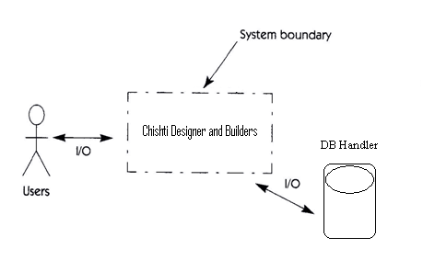

- Concept and range of proposed solution
Baiscally client/user wants to convert from manual database management system to an improved one. That is why, the main concept of the proposed system is to provide a system that allows the user to handle database management without maintaining manually records on registers or excel sheets. Solution was to provide ease of use to the users.
- What the system is
- Our proposed system will allow a fully automated system for customer’s record keeping.
- Searching, updating and record entry will be a click away.
- Much efficient and faster system that will allow backup and information security.
- System will give reminders and to-do list of every day to help the users remember important meetings and tasks.
- Customers will not have to wait much and they will be satisfied with the services of the company.

- Limitations The only limitation till now is
- verification of the entered users CINC confirmation is only possible by NADRA
if internet facility is available.

Major features planned for initial release
The key major features that are planned for the initial release are:
- Customer Record Keepings.
- New entries, Searching, updating, deleting, maintain backup etc.
- Providing Information Security.
- Reminders
- Calendar
- Entertainment
- Browser
Scope of subsequent releases
The main focus in the subsequent features of CDB would be better hardware, better software and more features.
So the subsequent releases shall consist of:
- Verification of CNIC by NADRA if client agrees via online.
- E-mailing of agreement record to user and the client both automatically, after agreement.

1.4.3 System Boundary
CDB is all about the database management, will be involving all the
employees working in the office, at the capacity of clerk or handling computer work.
Identifying the question answer by the Actors/actual users going to use this software are:- .
- Who will supply, use or remove information from the system?
Product will be provided by the “MCS Approved Installers”
- Who will operate the system?
The CDB shall be used by Clerks, Managers, Supervisors and Administrator etc.
- Who will perform system maintenance?
The CDB comes under life-time warranty. Each and every technical fault would be covered in that warranty. However the maintenance is provided by the technical staff of the manufacturers.
- Where does the system get its information?
Required data shall be fed into the system by the user manually.
- What other external systems will interact with the system?
None.

IDENTIFYING CONSTRAINTS
1.5 Identifying Constraints

Source | Consideration
Economic | - Budget of 25,000 Rs is allotted for project.  - 5000 Rs for Misc expenditures
Political | Inter-departmental problems
- Application will be installed/running in multiple machines in a building
- System will be requiring LAN or Wi-Fi connections for networking.
- Need at least 1xserver machine for the database maintenance.
Technical | Restriction in choice of technology
- currently running/installed windows components are
    - Windows XP, Win-7
    - .NET Framework 3.5
    - AutoCAD 2008
System | Windows needs to be installed are:-  - Windows server 2008” will be required for “server database maintenance”.  - Windows XP or Win-7 for the rest of the computers  - High Level Languages used  - Application server software shall be written in “Visual Studio 2008, C#”, supports “.NET Framework 3.5”  - Employee client software shall be written in “Visual Studio 2008, C#”, supports “.NET Framework 3.5”  - User client software shall be written in DHTML, CSS, and JavaScript WebPages (if necessary).  - Databases  - Where practical, data shall be defined and documented using “SQL server 2008”.  - Hardware Constraints  - Printer any (Laser or dot matrix) latest model attached to every system is necessary.
Environmental | Environmental or regulatory constraints  - This Application Is Purpose Full Only For Civil Engineers, Construction/Building Sites.  - No Security Constraint Because Admin and other users will have their passwords
Schedule and resources | Schedule  - Project will be Tested and deployed within the time frame of two month.  - Only three Computers will be available for the testing and validation in the domain area.  - If complete domain setup is to be used, then it will only be available on off days(Saturday, sunday)

